CKTrends

*A system for tracking your CloudKit database*

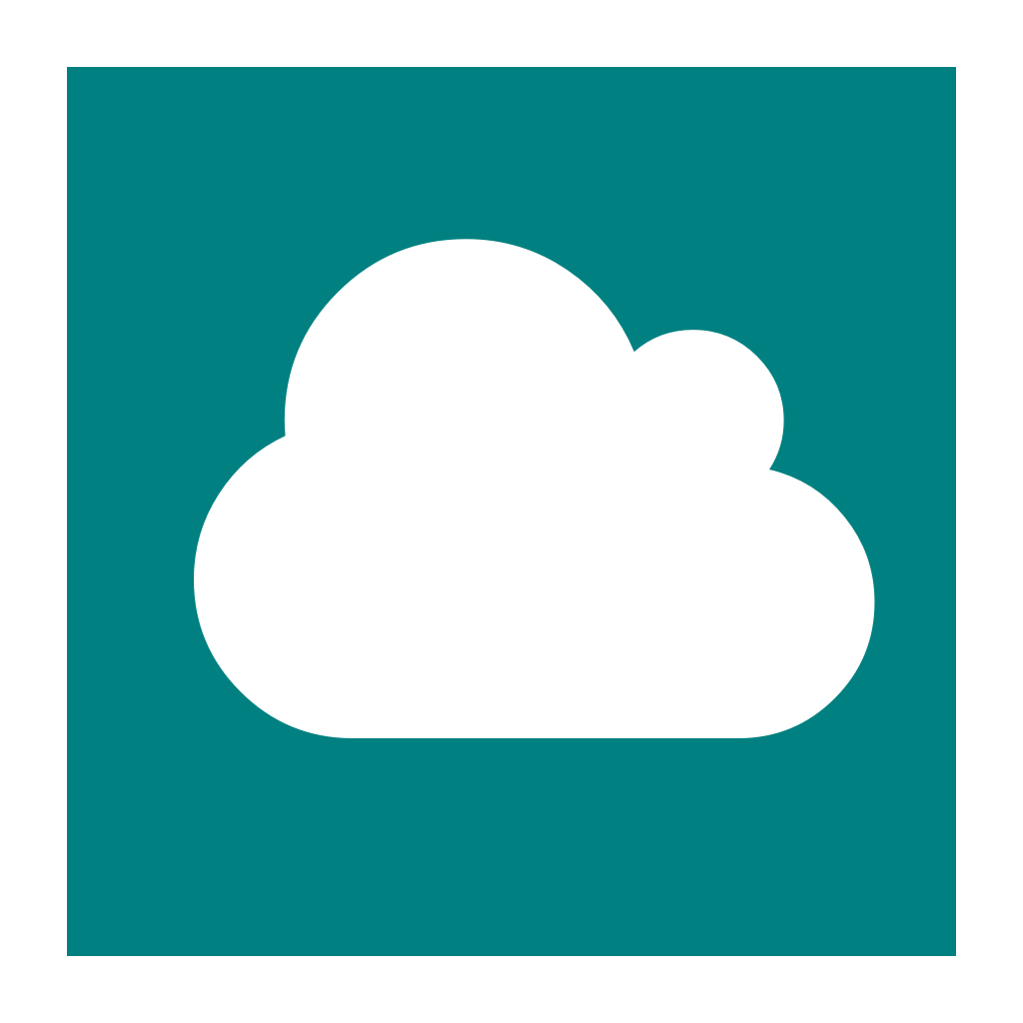

Marissa Le Coz

Dartmouth College

Advisor: Dr. Charles Palmer

Fall 2017 / Winter 2018

COSC 297

**I. Motivation**

In May 2017, my first app, NovenaNetwork, was accepted by the App Store. As is the case for any new iOS developer, I was very excited to monitor my app’s downloads and watch my user base grow. I soon discovered Apple’s “iTunes Connect” app, which allows you to see the number of downloads your app gets each day. Although iTunes Connect was slow and inconsistently updated, I was still able to get a snapshot of how NovenaNetwork was doing. That is, until late August 2017.

One day in August, I opened iTunes Connect and found that NovenaNetwork had apparently been downloaded over 1000 times in one day in China. This was a major outlier compared with the rest of my statistics. Had NovenaNetwork gone viral in China? Given that NovenaNetwork is a distinctly Catholic app and given the level of religious persecution in China, this seemed highly unlikely. So I did some research.

Apparently there are cheater companies that some iOS developers pay to download and rate their apps. These cheater companies have tons of virtual devices that they use to download an app many times. To mask what they are doing, the cheater companies additionally download a bunch of free apps, like NovenaNetwork. Sure enough, when I checked my CloudKit[1] database for NovenaNetwork, there most certainly were not 1000+ new User records, supporting the hypothesis that the “new users” I saw in iTunes Connect were not real users at all.

Once NovenaNetwork’s statistics began to be skewed by the cheater companies’ nefarious work, I could no longer rely on iTunes Connect for trustworthy information. Whenever I wanted to gauge user activity on NovenaNetwork, I had to go straight to my CloudKit database dashboard online and execute a query for new users, new posts, etc. This was not ideal for a multitude of reasons. First, I really needed to use a laptop to properly view the CloudKit dashboard, so I could not check my statistics on the go, as I could with iTunes Connect. Second, drawing conclusions from the database required a lot of mental processing on my part; databases on their own do not display data in any visually enlightening way. Third, query results in the dashboard were limited to a certain number of records (which I did not realize until much later), so it was impossible to get a full snapshot of the state of NovenaNetwork.

**II. Solution**

I realized that the only way that I could get a good representation of NovenaNetwork’s true trends would be to create a visualization app that would somehow have access to NovenaNetwork’s CloudKit database. CKTrends is this app.

CKTrends allows developers to track any custom record types in their CloudKit database. For each record type, CKTrends displays a bar graph showing the number of instances of that record type created on each day. Developers can scroll through dates all the way to the very first date that an instance of that record type was created. Not only can any number of record types be monitored for any given app, but also any number of apps (each with their own CloudKit database) can be tracked by CKTrends.

Additionally, developers can track the number of elements in a list that is an attribute of some record type, assuming exactly one instance of this record type in the database. This is useful if the developer has structured his/her database such that there is some record that contains a “master list” of some important elements.

The CKTrends concept sounds straightforward enough, but now onto the real question: how does the data get to CKTrends? Herein lies the bulk of the system.

**III. The Pipeline, Part 1:**

1. CloudKit is Apple’s built-in cloud database for apps built on Apple platforms. CloudKit database are, for the most part, one-to-one: one app, one CloudKit database.